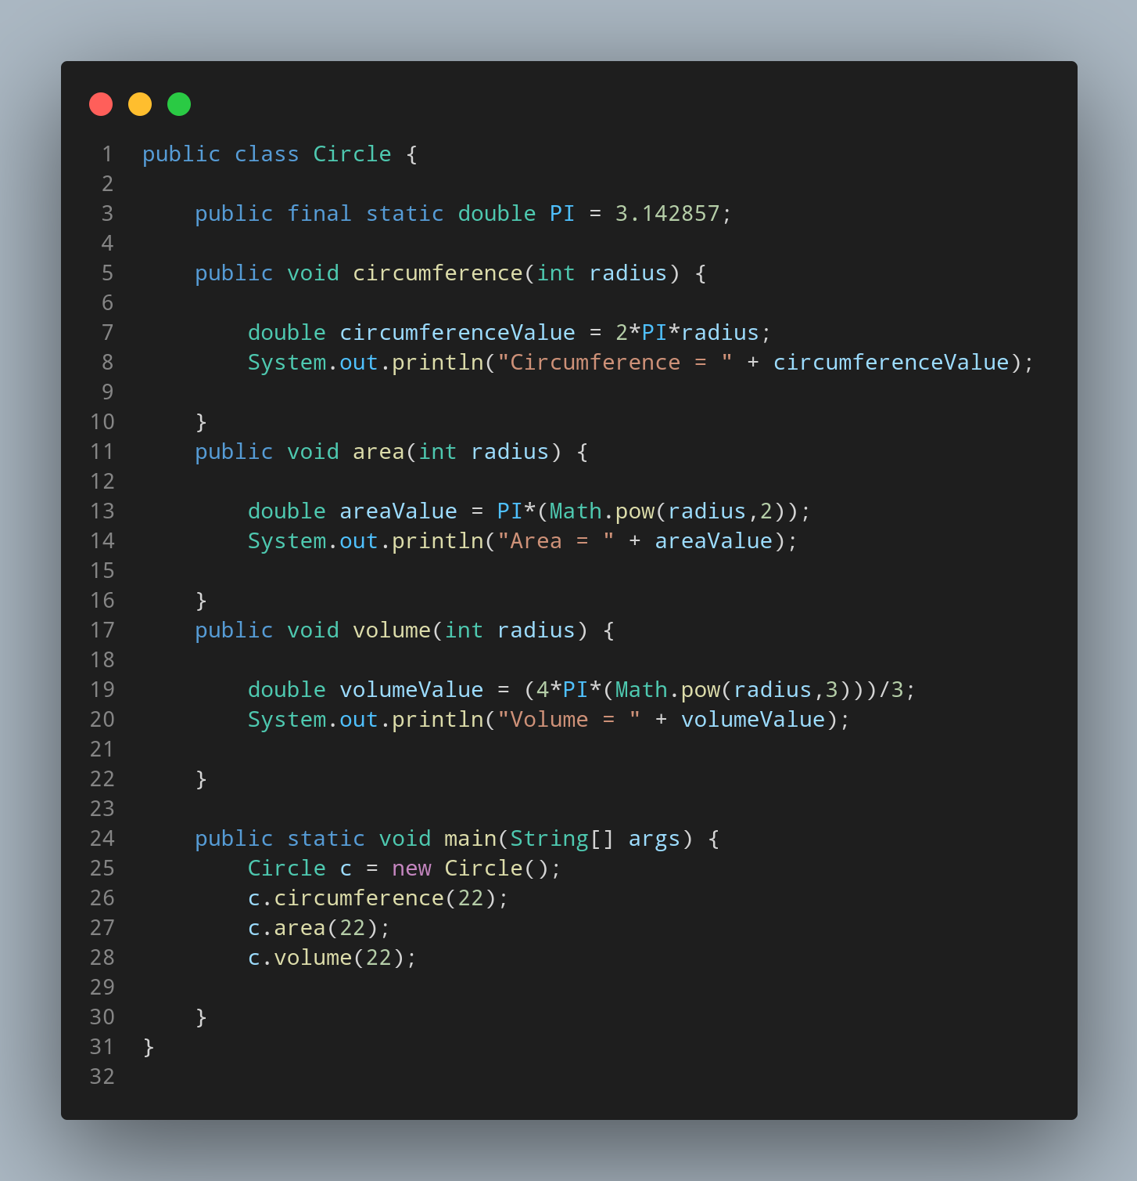

#Doc

We created our java file naming Circle so , we create a class having same name. Inside cour class we define a constant having data type double to store the value of PI.

Then we created a method named circumference having int radius as parameter. Then we created a variable to store our circumference calculated value named as circumferenceValue with leteral 2*PI*radius.

Then we print our variable with suitable strings.

Then we created a method named carea having int radius as parameter. Then we created a variable to store our area calculated value named as areaValue with leteral PI*(Math.pow(radius,2)).

Then we print our variable with suitable strings.

Then we created a method named volume having int radius as parameter. Then we created a variable to store our volume calculated value named as volumeValue with leteral (4*PI*(Math.pow(radius,3)))/3.

Now its time to create our main function.
Within main function first we instantiate our Circle class data type as variable c. Then we call our method giving the value of function parameter during calling method.

